**Advanced Mathematics**

Lab 11

Yu-Hao Chiang 3443130

**Exercise 1 – bathymetric data**



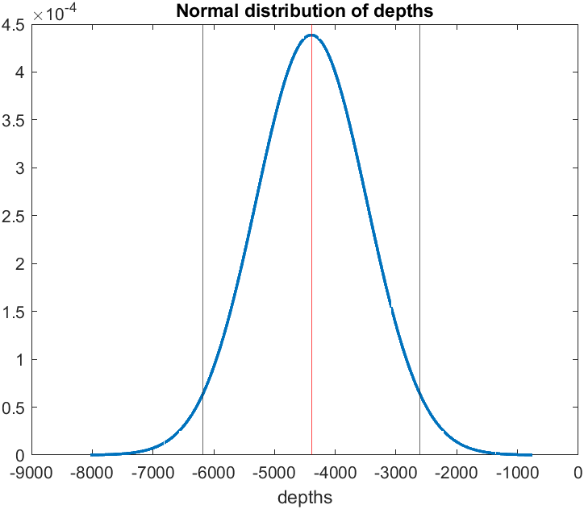

Figure 1 normal distribution of depths

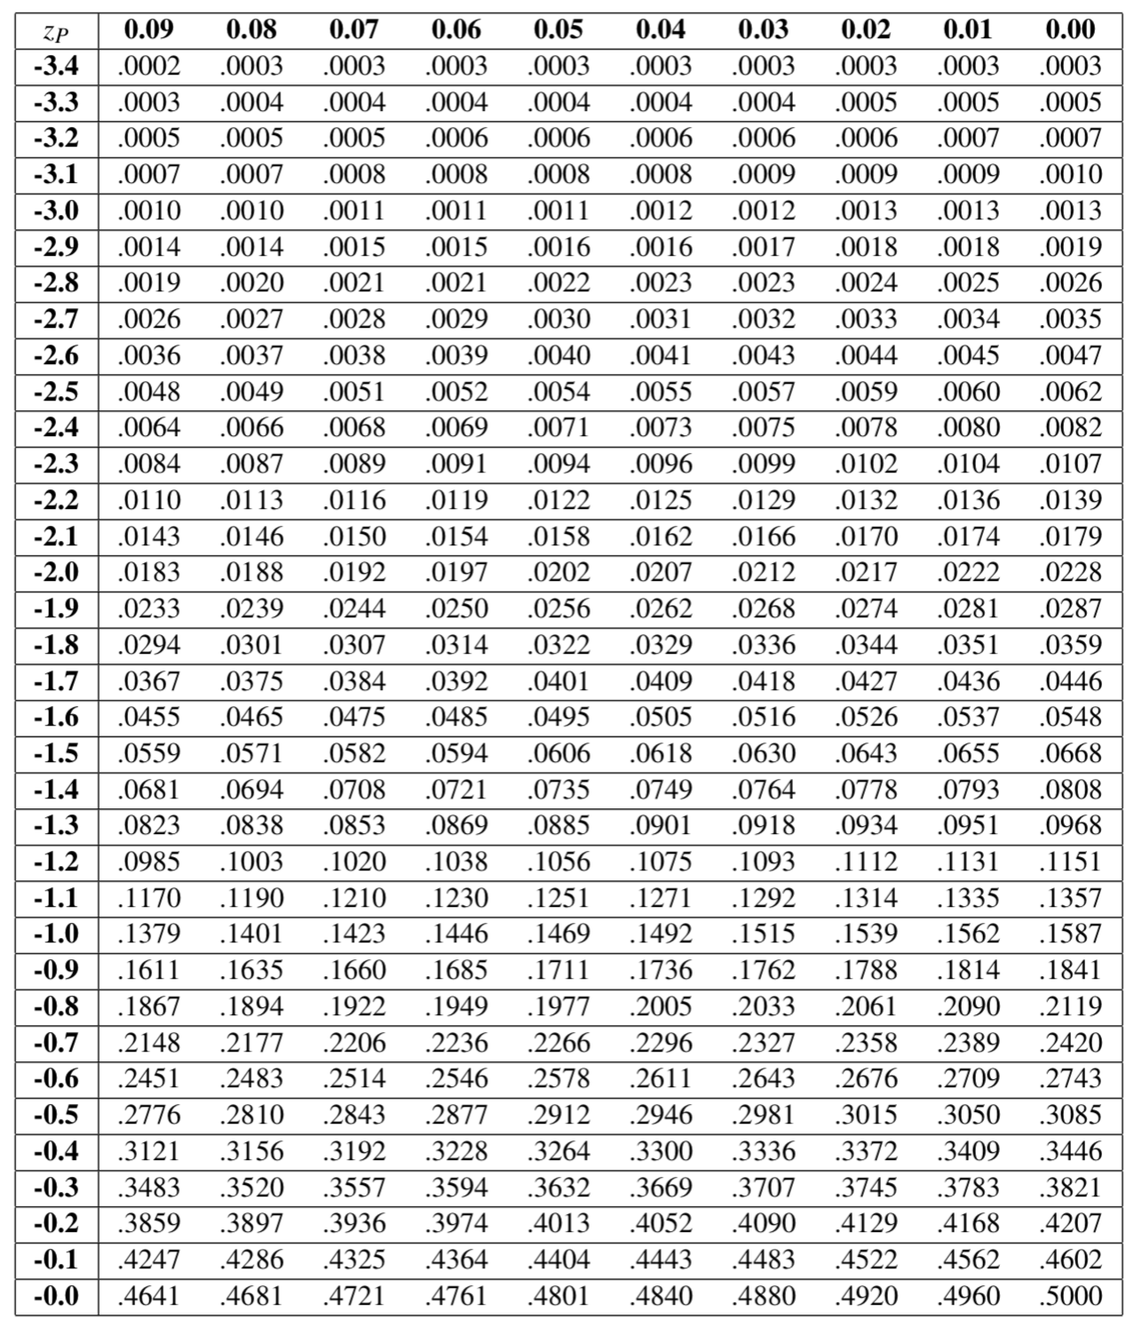

Table 1 Normal cumulative distribution function

**Exercise 2 – plane booking**

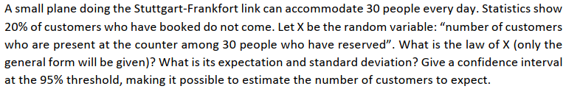

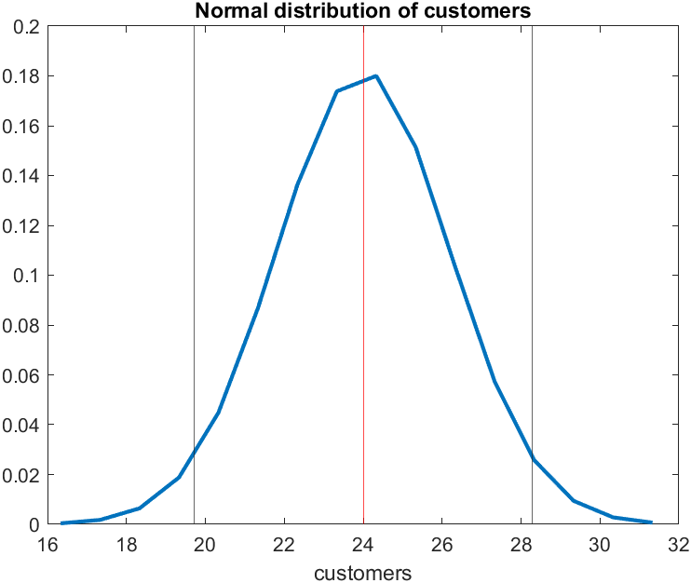

Figure 2 normal distribution of customers reserved the plane per day

**Exercise 3 – water contents of soils**



For a two-tails test, we compute, Look at the critical values for the student's distribution, using 99% confidence level, we can obtain the critical t value is 2.609.

We find the by evaluating.

The absolute value of the test statistic is less than the critical value (2.609), then we **accept** the null hypothesis ().

The t distribution is symmetric so that:

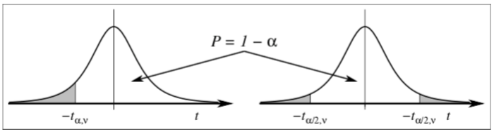

Figure 3

**Exercise 4 – toxic algae on beaches**

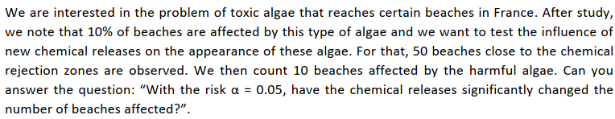

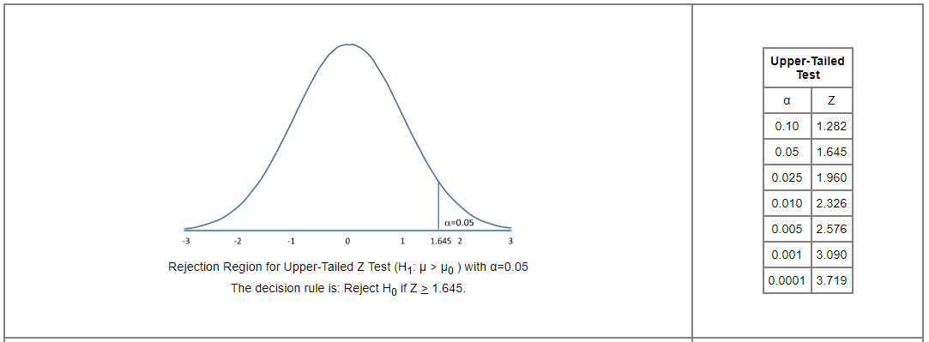

Figure 4 Upper-Tailed Z test

**Exercise 5 – sulfur dioxide emissions**

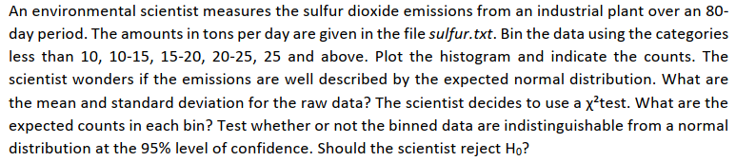

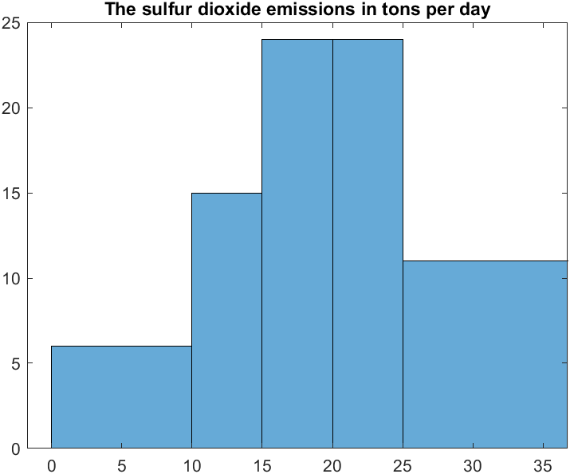

Figure 5 The sulfur dioxide emissions in tons per day.

|  |  |
| --- | --- |
|  |  |
|  |  |
|  |  |
|  |  |
|  |  |
|  |  |

The distribution depends on , the degrees of freedom, which normally would be in our case (we lost one case since the bin counts must sum to n). However, we also used our observations to compute , then s, in order to determine the bin boundaries. These estimations further reduce by two, leaving just two degrees of freedom.

Since it is much larger than our computed value, we conclude that we cannot at the 0.05 level of confidence reject the null hypothesis (**accept**)

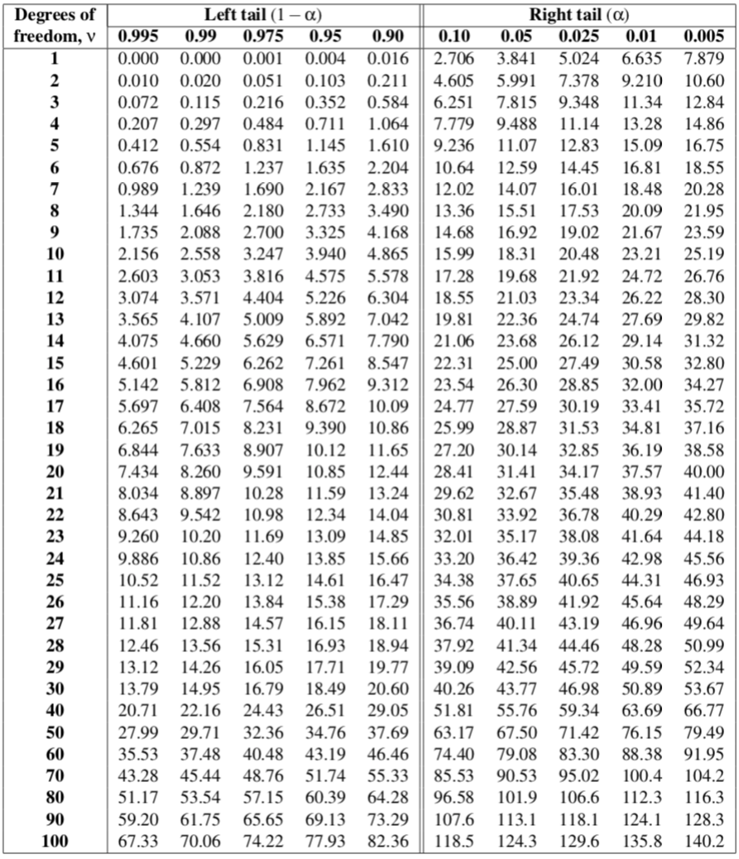

Table 2 Critical values for the distribution